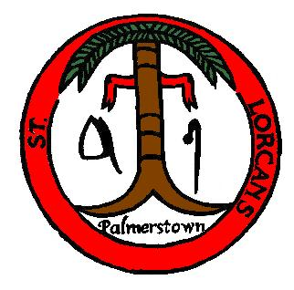

St. Lorcan’s B.N.S.
ANNUAL ADMISSION NOTICE
In respect of admissions to the 2023/2024 school year

Admission Policy and Application Form
A copy of the school’s Admission Policy and the Application Form for Admission for 2023/2024 is available as follows: www.stlorcans.com
On request: By emailing: office@stlorcansbns.com or in writing to: School Secretary, St. Lorcan’s BNS, Palmerstown, Dublin 20.

Admissions to the St. Lorcan’s BNS 2023/2024 school year

Application and Decision Dates for admission to Junior Infants for the school year 2023/24
The following are the dates applicable for admission to Junior Infants:

The school will commence accepting applications for admission on | 7th Nov 2022
The school shall cease accepting applications for admission on | 26t^{h} May 2022
The date by which applicants will be notified of the decision on their application is | 16th June 2022
The period within which applicants must confirm acceptance of an offer of admission is | 28th June 2022

*Failure to accept an offer within the prescribed period above may result in the offer being withdrawn
Note: the school will consider and issue decisions on late applications in accordance with the school’s Admission Policy.

Number of places being made available in St. Lorcan’s BNS 2023/2024

The number of places being made available in Junior Infants this year is | 60

